Titleofthearticle
FirstAuthor¹,SecondAuthor², and Third Author³
¹Department,University,City,Country(E-mail: ﬁrstauthor@email.com)
²Department,University,City,Country(E-mail: secondauthor@email.com)
³Department,University,City,Country(E-mail: thirdauthor@email.com)

Preprint submitted to RGN Publications onDay/Month/Year

Abstract
Abstract should not more than 250 words.

2010 AMS Classification:
Keywords and phrases:

Article type: (Please select only one type) Research article or Survey article or Book Review or Case Study or Thesis Abstract or Bibliographic work
1 Introduction
YourTexthere
2 Equations
Let us see how easy it is to write equations with help of Word 2010’s equation editor.
$$Δ=\sum_{i=1}^{N}{w_{i}{\left(x_{i}-\overline{x}\right)}^{2}}.$$
Itis agoodideato numberequations,but we canhave a equation without a numberby writing
$$P\left(x\right)=\frac{x-a}{b-a}.$$

3 Tables
Sample Table

Lattice | 2 | 4 | 1.763
Square | 2 | 6 | 1.648
triangular | 2 | 4 | 1.479
Simple cubic | 3 | 6 | 1.330

Table1:Comparisonof themean-fieldpredictionsforthecritical temperatureof theIsing model with exact results and the best known estimates for different spatial dimensions dandlattice symmetries.

4 Lists
Some example of formatted lists include the following:
- bread
- cheese
- Tom
- Dick

5 Figures
We can make figures bigger or smaller by scaling them. Figure 2 has been scaled by 60%.

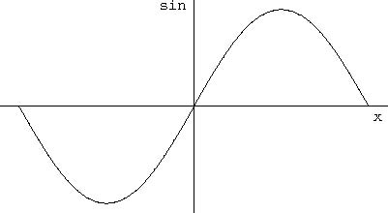
Figure 1: Show me a sine.
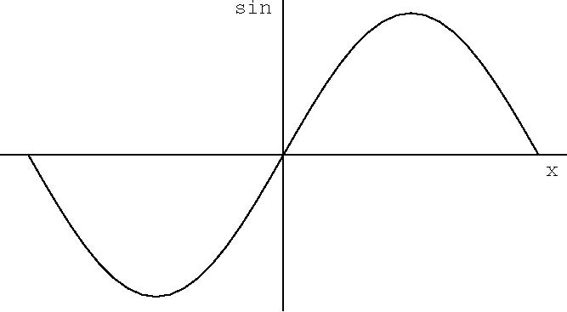
Figure 2: Plot of the Lennard-Jones potential u(r). The potential is characterized by a length σand an energy ǫ.
Acknowledgement
Detail of research grants etc. ..........
References
[1] W.N. Anderson, Jr. and R.J. Duffin, Series and parallel addition of matrices, Journal of Mathematical Analysis and Applications 26 (1969), 576–594.
[2] F.F. Bonsall and D.S.G. Stirling, Square roots in Banach §-algebras, Glasgow Math. J. 13 (74), 1972.
[3] R.A. Horn and C.R. Johnson, Matrix Analysis , Cambridge University Press (1985).
[4] A.V. Ramakrishna and T.V.N. Prasanna, Symmetric circulant matrices and publickey cryptography, Int. J. Contemp. Math. Sciences 8 (12) (2013), 589–593.

